Name:
Date:
Magpie Chatbot Lab
Directions: Make note of your responses to the following questions as you work through activities 4 and 5 of the AP Computer Science Lab Student Guide: Magpie.

Activity 4
- In the Exploration section, how does the Magpie chatbot respond to:
I want to build a robot. | What would it mean to build a robot?
I want to understand French. | What would it mean to understand French?
Do you like me? | What makes you think I like you
You confuse me. | What makes you think I confuse you?

- After altering the code, test the code by chatting with Magpie. Test statements in the form of "I want to something", "I want something", "you something me", and "I something you". Paste your conversation below.
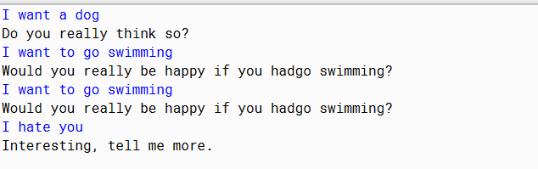
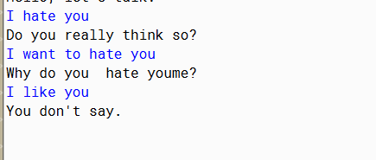
- When altering the code, why did you need to be careful about where you place the check for "I want something" statements? Use the samples to determine your answer.
I needed to be careful where I put the checks so that ways the machine can properly understand what type of question I am asking. This is better seen with sentence 2 giving a wrong reply as a result.

Activity 5
- Imagine you were to interview an end user and ask them to compare the version of the program before the array was added to getRandomResponse and the version after. What might they say?
They might not notice any difference as this is all framework changes with very few system.out.print changes. So, the only thing they would say is commenting on the two new responses I added.

- Now interview the programmer for the code. How might he/she compare and contrast the two programs? Are the end user’s and programmer’s responses similar? Why?

They would probably say that the array version would be easier to digest as there would be less initializing new responses in every line and instead store everything nice and neatly in the array. Additionally, utilizing an array, I can call on the array based off the if statement. Such as if (response =0 ) All I have to do is use response = potentialResponse[0] making it a lot more easier to debug. They will not be similar as one has access to the code and the other doesn’t (Not sure what google inspect does and doesn’t show you so perhaps they both have access).

